**Lesson 21 Encryption**

**Symmetric encryption**

a type of encryption where only one key (a secret key) is used to both encrypt and decrypt electronic information. Public key

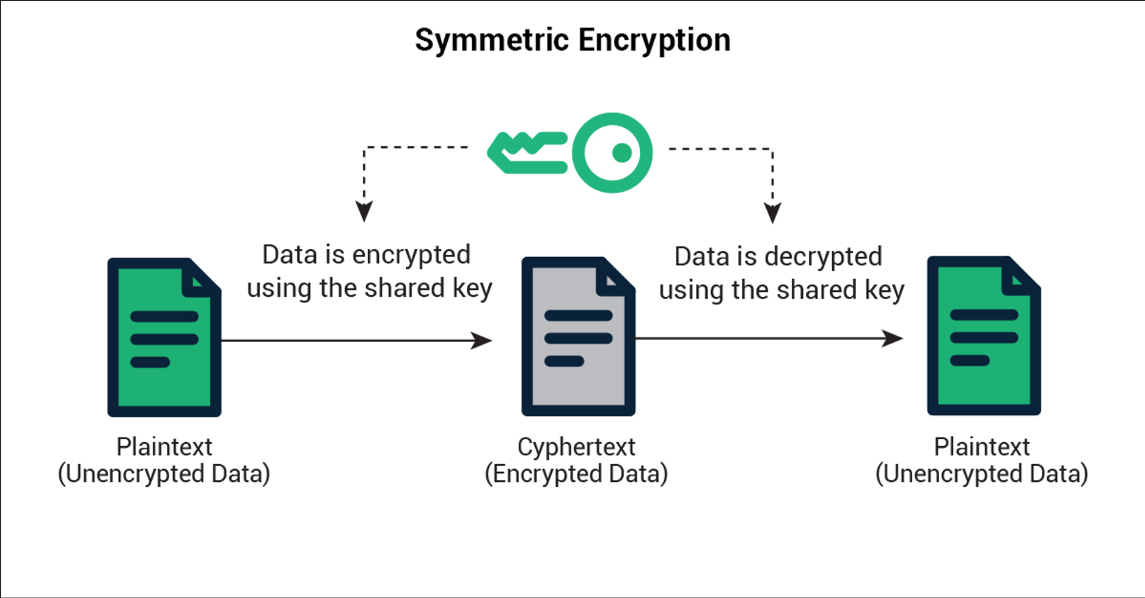

**Asymmetric encryption**

Asymmetric Encryption, also known as Public-Key Cryptography, is an example of one type. Unlike “normal” (symmetric) encryption, Asymmetric Encryption encrypts and decrypts the data using two separates yet mathematically connected cryptographic keys.

